**pygame Installation Instructions** (admin privileges are required)

1. Download the following files:
   1. python-3.6.2-macosx10.6.pkg
      1. <https://www.python.org/ftp/python/3.6.2/python-3.6.2-macosx10.6.pkg>
   2. wingide-personal-6.0.7-1.dmg
      1. <http://wingware.com/pub/wingide-personal/6.0.7/wingide-personal-6.0.7-1.dmg>
   3. (Optional) Place the files in a folder on the Desktop called Python_Install_Files
2. Install Python 3.6.2 by following this process:
   1. Click on ‘python-3.6.2-macosx10.6.pkg’.
   2. Keep clicking ‘Continue’ until the installation window appears, then click ‘Install’. When prompted with a pop-up window, click ‘Agree’.
   3. The installation process is automatic.
   4. There should now be a folder called ‘Python 3.6’ in Applications.
3. Install the Wing IDE by following this process:
   1. Click on ‘wingide-personal-6.0.7-1.dmg’.
   2. A window should appear with two items: An application called ‘WingPersonal’ and a shortcut for the Applications folder. Drag the application into the folder.
   3. WingPersonal should appear in Applications. To see if the application is working properly, follow this process to make a sample Python program:
      1. Open WingPersonal. If prompted with a window with the options ‘Open’ and ‘Cancel’, choose ‘Open’. Agree to the License Agreement. Close the window that appears at startup to reveal the project window.
      2. Click the blue file icon in the top-left or select ‘File’ -> ‘New’ from the menubar to create a new Python file. Click ‘Debug I/O’ in the bottom-right to show output. Type print(“hello world”) into the text field.  
         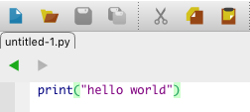
      3. Click the Green Arrow icon in the top-right to run the program. After clicking ‘OK’ and saving the file, the output field below ‘Debug I/O’ should look something like this:  
         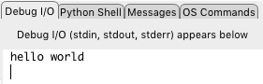
4. Install pygame by following this process:
   1. Open Terminal.
   2. Type login admin. An administrator password is required.
   3. Type sudo pip3 install pygame. Once again, an administrator password is required.
      1. The installation process is automatic. If there are no issues, the Terminal output should look something like this:  
         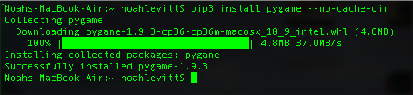
   4. pygame should now be installed. Students should now be able to run their pygame code through Terminal, but just in case, to test if pygame is working properly, follow this process:
      1. Type python3 -m pygame.examples.aliens and press enter.
      2. If there are no issues, a simple alien game will load in a separate window.

**Additional Notes: How to run a program in Python 3**

1. To run any Python 3 program through Terminal, navigate to the directory of the file (using cd and ls) and type python3 before the file name at the command prompt.  
    (e.g. python3 example.py)
2. To configure WingIDE to run a program in Python 3, follow this process:
   1. Select Project’ -> ‘Project Properties’ from the menu bar.
   2. To the right of to ‘Python Executable’, select ‘Custom’ if it is not selected already.
   3. A down arrow should be visible to the right to the blank text box. Click on it and select the path that looks like this:  
      ‘/Library/Frameworks/Python.framework/Versions/3.6/bin/python3.6’
      1. If the text box is not blank, make sure that the path is the same as the one shown above - otherwise, follow the step above.
   4. Click ‘Apply’ or ‘OK’ to save this change. The project should now be configured to run in Python 3.
      1. *Note: This process will have to be repeated for future projects, as each individual project is configured by default to use the Python 2 executable.*
   5. To test whether the process was followed successfully, run the following code from the newly configured project:  
      print(raw_input(‘Enter something: ‘))
      1. If the code is executed in Python 3, a ‘NameError’ will occur, since the raw_input() function is not defined in Python 3.